AI Assignment-10

Jeetu Mehra
U24AI032

Question 1 : 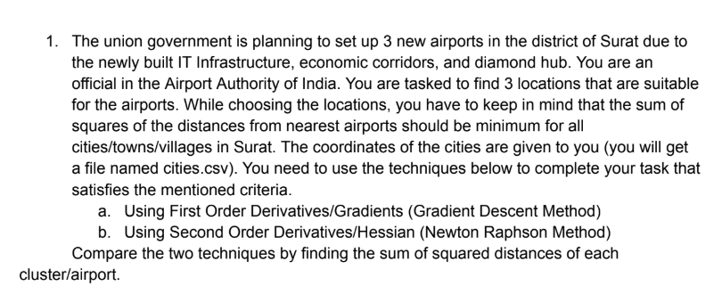
Code:
#include <iostream>
#include <fstream>
#include <sstream>
#include <vector>
#include <cmath>
#include <limits>
#include <iomanip>
using namespace std;
struct Point {
double x, y;
};

vector<Point> loadCSV(const string& filename) {
vector<Point> cities;
ifstream file(filename);
string line;

if (!file) {
cout << "Error: File not found!" << endl;
return cities;
}

while (getline(file, line)) {
if (line.empty()) continue; // skip empty lines

stringstream ss(line);
string xStr, yStr;

getline(ss, xStr, ',');
getline(ss, yStr, ',');

// skip invalid lines like ","
if (xStr.empty() || yStr.empty()) continue;

try {
cities.push_back({stod(xStr), stod(yStr)});
} catch (...) {
cout << "Skipping invalid line: " << line << endl;
}
}

return cities;
}
double squaredDist(Point a, Point b) {
return (a.x - b.x)*(a.x - b.x) + (a.y - b.y)*(a.y - b.y);
}
vector<int> assignClusters(const vector<Point>& cities, const vector<Point>& airports) {
vector<int> labels(cities.size());
for (int i = 0; i < cities.size(); i++) {
double minDist = numeric_limits<double>::max();
int best = 0;
for (int k = 0; k < airports.size(); k++) {
double d = squaredDist(cities[i], airports[k]);
if (d < minDist) {
minDist = d;
best = k;
}
}
labels[i] = best;
}
return labels;
}
double totalSSD(const vector<Point>& cities, const vector<Point>& airports, const vector<int>& labels) {
double total = 0;
for (int i = 0; i < cities.size(); i++) {
total += squaredDist(cities[i], airports[labels[i]]);
}
return total;
}
vector<Point> gradientDescent(const vector<Point>& cities, vector<Point> airports,
double learningRate = 0.01, int maxIter = 1000) {
int K = airports.size();

for (int iter = 0; iter < maxIter; iter++) {
vector<int> labels = assignClusters(cities, airports);

vector<Point> newAirports = airports;
bool converged = true;

for (int k = 0; k < K; k++) {
double sumX = 0, sumY = 0;
int count = 0;
for (int i = 0; i < cities.size(); i++) {
if (labels[i] == k) {
sumX += cities[i].x;
sumY += cities[i].y;
count++;
}
}
if (count == 0) continue;
double gradX = 2.0 * (count * airports[k].x - sumX);
double gradY = 2.0 * (count * airports[k].y - sumY);
newAirports[k].x = airports[k].x - learningRate * gradX;
newAirports[k].y = airports[k].y - learningRate * gradY;
if (fabs(newAirports[k].x - airports[k].x) > 1e-6 ||
fabs(newAirports[k].y - airports[k].y) > 1e-6) {
converged = false;
}
}
airports = newAirports;
if (converged) {
cout << " [GD] Converged at iteration " << iter << endl;
break;
}
}
return airports;
}
vector<Point> newtonRaphson(const vector<Point>& cities, vector<Point> airports,
int maxIter = 1000) {
int K = airports.size();
for (int iter = 0; iter < maxIter; iter++) {
vector<int> labels = assignClusters(cities, airports);
vector<Point> newAirports = airports;
bool converged = true;
for (int k = 0; k < K; k++) {
double sumX = 0, sumY = 0;
int count = 0;
for (int i = 0; i < cities.size(); i++) {
if (labels[i] == k) {
sumX += cities[i].x;
sumY += cities[i].y;
count++;
}
}
if (count == 0) continue;
double gradX = 2.0 * (count * airports[k].x - sumX);
double gradY = 2.0 * (count * airports[k].y - sumY);
double hessX = 2.0 * count;
double hessY = 2.0 * count;
newAirports[k].x = airports[k].x - gradX / hessX;
newAirports[k].y = airports[k].y - gradY / hessY;
if (fabs(newAirports[k].x - airports[k].x) > 1e-6 ||
fabs(newAirports[k].y - airports[k].y) > 1e-6) {
converged = false;
}
}
airports = newAirports;
if (converged) {
cout << " [NR] Converged at iteration " << iter << endl;
break;
}
}
return airports;
}
void printResults(const string& method, const vector<Point>& airports,
const vector<Point>& cities) {
vector<int> labels = assignClusters(cities, airports);
double ssd = totalSSD(cities, airports, labels);
cout << "\n========== " << method << " ==========\n";
for (int k = 0; k < airports.size(); k++) {
int count = 0;
for (int l : labels) if (l == k) count++;
cout << "Airport " << k+1 << ": ("
<< fixed << setprecision(4) << airports[k].x
<< ", " << airports[k].y << ")"
<< " [" << count << " cities assigned]\n";
}
cout << "Total Sum of Squared Distances: " << fixed << setprecision(4) << ssd << "\n";
}
int main() {
vector<Point> cities = loadCSV("cities.csv");
cout << "Loaded " << cities.size() << " cities.\n";
vector<Point> initAirports = {
{0.0, 0.0},
{0.0, 5.0},
{5.0, 5.0}
};
cout << "\nRunning Gradient Descent...\n";
vector<Point> gdAirports = gradientDescent(cities, initAirports, 0.001, 10000);
printResults("GRADIENT DESCENT", gdAirports, cities);
cout << "\nRunning Newton-Raphson...\n";
vector<Point> nrAirports = newtonRaphson(cities, initAirports, 1000);
printResults("NEWTON-RAPHSON", nrAirports, cities);
{
vector<int> gdLabels = assignClusters(cities, gdAirports);
vector<int> nrLabels = assignClusters(cities, nrAirports);
double gdSSD = totalSSD(cities, gdAirports, gdLabels);
double nrSSD = totalSSD(cities, nrAirports, nrLabels);

cout << "\n========== COMPARISON ==========\n";
cout << "Gradient Descent SSD : " << fixed << setprecision(4) << gdSSD << "\n";
cout << "Newton-Raphson SSD : " << fixed << setprecision(4) << nrSSD << "\n";
if (gdSSD < nrSSD)
cout << "Winner: Gradient Descent\n";
else if (nrSSD < gdSSD)
cout << "Winner: Newton-Raphson\n";
else
cout << "Both methods give same result.\n";
}
return 0;
}

Question 2 :
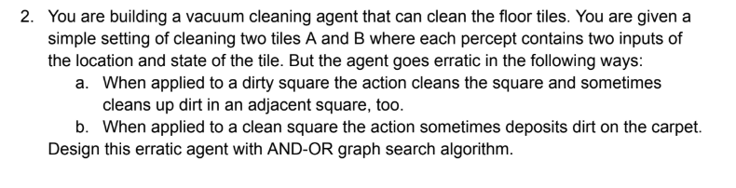

Code:
# Erratic Vacuum Cleaner AND-OR Graph Search

# State representation: (Location, A_state, B_state)
# Location = 'A' or 'B'
# State = 'Dirty' or 'Clean'

goal_state = ('*', 'Clean', 'Clean')

def is_goal(state):
return state[1] == 'Clean' and state[2] == 'Clean'

def results(state, action):
location, A, B = state
outcomes = []

if action == "Suck":
if location == 'A':
if A == 'Dirty':
# Clean A, maybe clean B too
outcomes.append(('A', 'Clean', B))
outcomes.append(('A', 'Clean', 'Clean'))
else:
# Dirt may be deposited
outcomes.append(('A', 'Dirty', B))
elif location == 'B':
if B == 'Dirty':
outcomes.append(('B', A, 'Clean'))
outcomes.append(('B', 'Clean', 'Clean'))
else:
outcomes.append(('B', A, 'Dirty'))

elif action == "Left":
outcomes.append(('A', A, B))

elif action == "Right":
outcomes.append(('B', A, B))

return outcomes

def actions(state):
return ["Suck", "Left", "Right"]

def and_or_search(state, path):
if is_goal(state):
return []

if state in path:
return None

for action in actions(state):
result_states = results(state, action)

plans = []
for s in result_states:
plan = and_or_search(s, path + [state])
if plan is None:
plans = None
break
plans.append(plan)

if plans is not None:
return [action, plans]

return None

# Initial state
initial_state = ('A', 'Dirty', 'Dirty')

plan = and_or_search(initial_state, [])

print("Conditional Plan:")
print(plan)

